**Weekly Data Computation at a Large Scale**

**Network Summary.**

|  |  |  |  |  |  |  |  |
| --- | --- | --- | --- | --- | --- | --- | --- |
| Instance | A | B | C | D | E | F | G |
| Nodes | 553 | 738 | 1512 | 1445 | 1636 | 1528 | 1636 |
| Edges | 530 | 722 | 1510 | 1501 | 2124 | 2511 | 4248 |
| Computation Time | 7.581 | 10.544 | 25.254 | 25.131 | 41.543 | 31.928 | 142.045 |

**Costing Summary**

|  |  |  |  |  |  |  |  |
| --- | --- | --- | --- | --- | --- | --- | --- |
| Instance | A | B | C | D | E | F | G |
| Total Cost | 12936.34 | 16119.47 | 2000 | 11093.73 | 2000 | 13014.95 | 4000 |
| Traction Unit Cost | 12000 | 15000 | 2000 | 11000 | 2000 | 13000 | 4000 |
| Light Travel Cost | 936.34 | 1119.47 | 0 | 93.73 | 0 | 14.95 | 0 |
| Traction Units Used | 12 | 15 | 2 | 11 | 2 | 13 | 4 |

**Robustness Calculation**

|  |  |  |  |  |  |  |  |
| --- | --- | --- | --- | --- | --- | --- | --- |
| Instances | A | B | C | D | E | F | G |
| Tight Connections Found | 5 | 5 | 0 | 4 | 0 | 33 | 0 |
| Buffer Applied to tight connections | 600s | 600s | 0 | 600s | 0 | 600s | 0 |
| Traction Units Used | 12 | 15 | 2 | 11 | 2 | 13 | 4 |
| Light Travel Cost | 936.34 | 1119.47 | 0 | 93.73 | 0 | 14.95 | 0 |
| Total Cost | 12936.34 | 16119.47 | 2000 | 11093.73 | 2000 | 13014.95 | 4000 |

**Instance A.**

**Unpotimized Space Time Network**

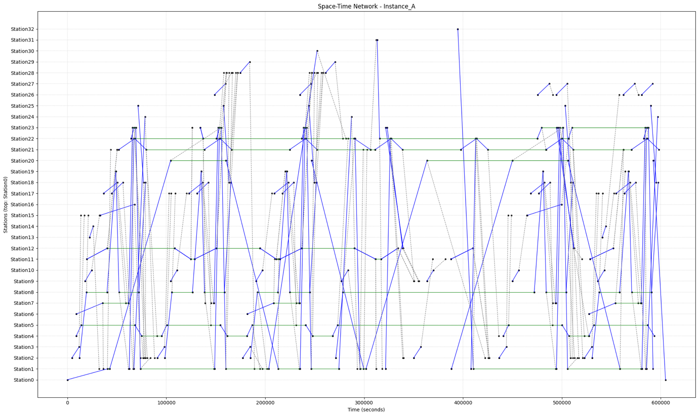

**Optimized Space Time Network**

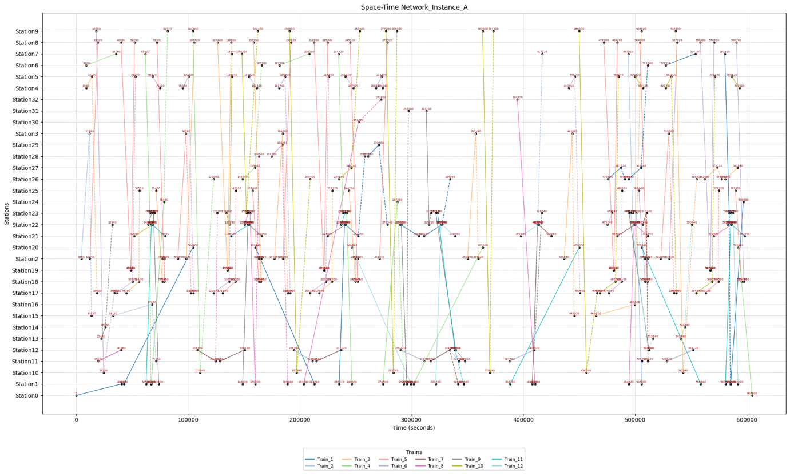

**Robust Space Time Network**

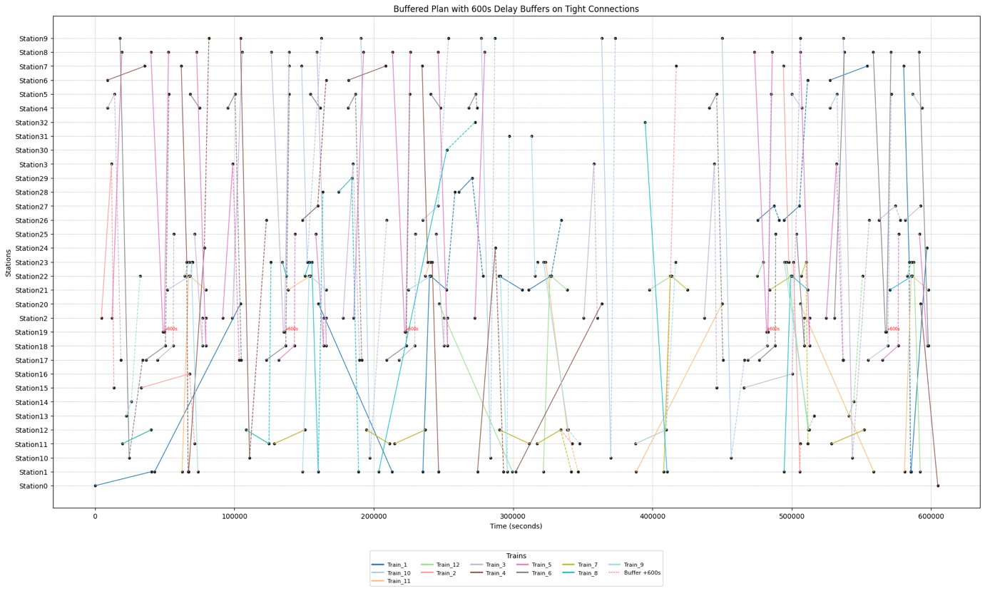

**Instance B**

**Unoptimized Space-time Network**

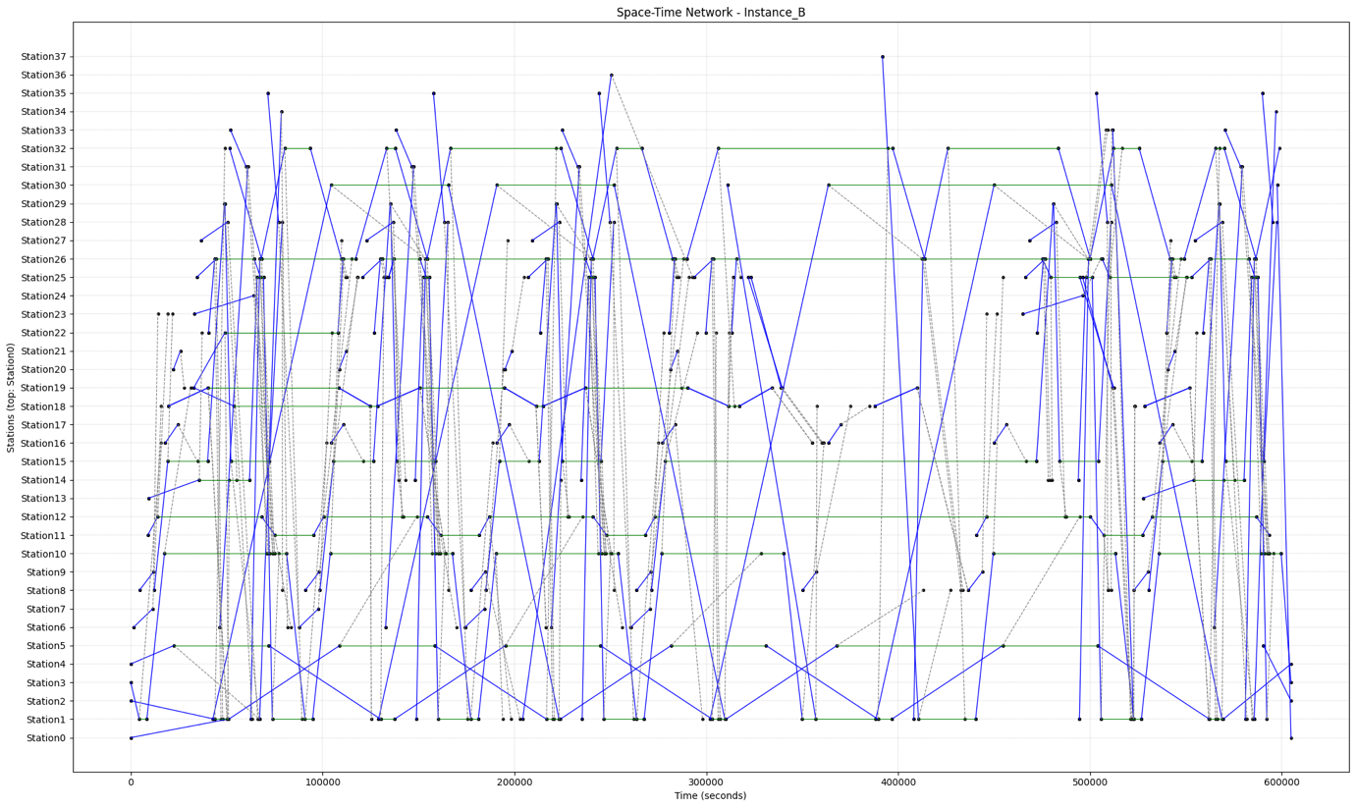

**Optimized Space-time Network**

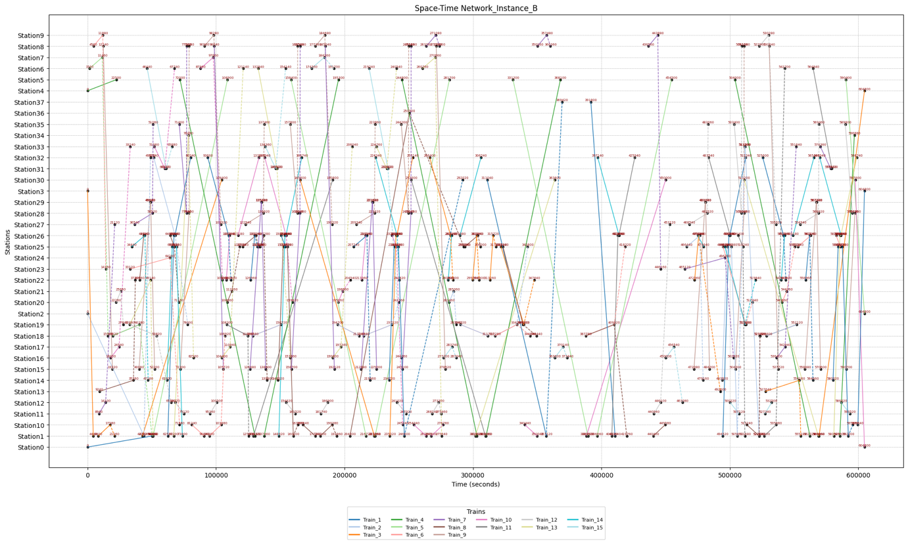

**Robust Space-Time Network**

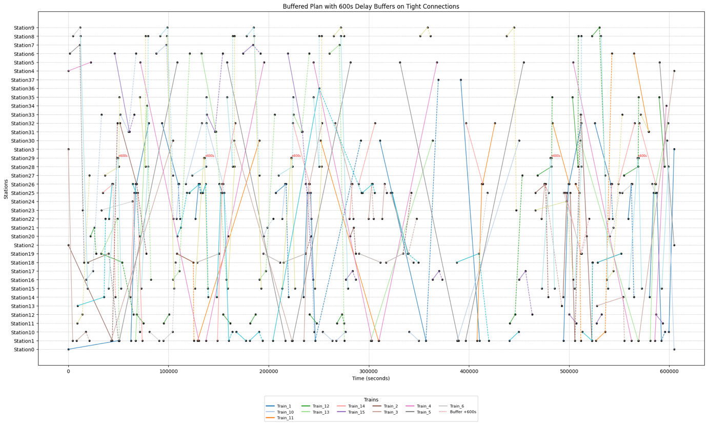

**Instance C**

**Unoptimized Space-time Network**

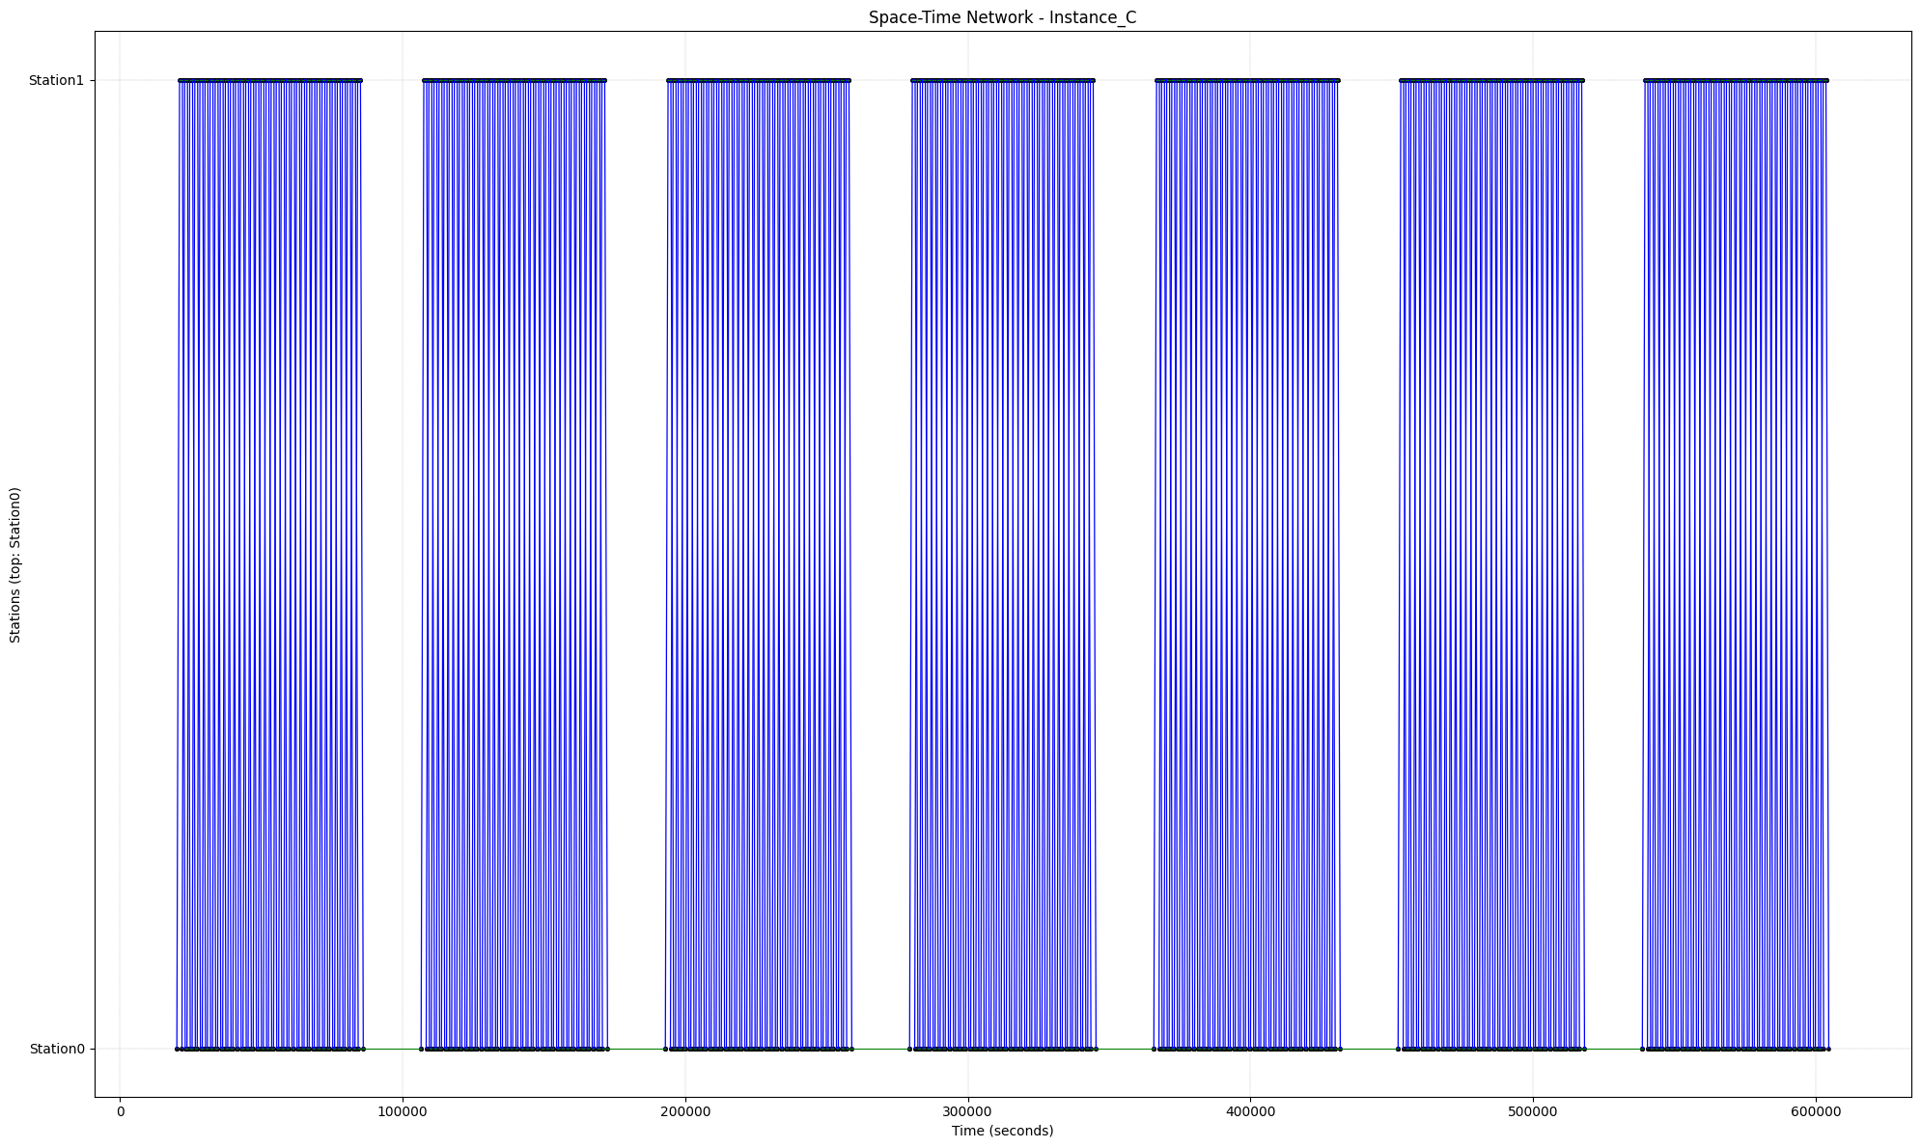

**Optimized Space Time Network**

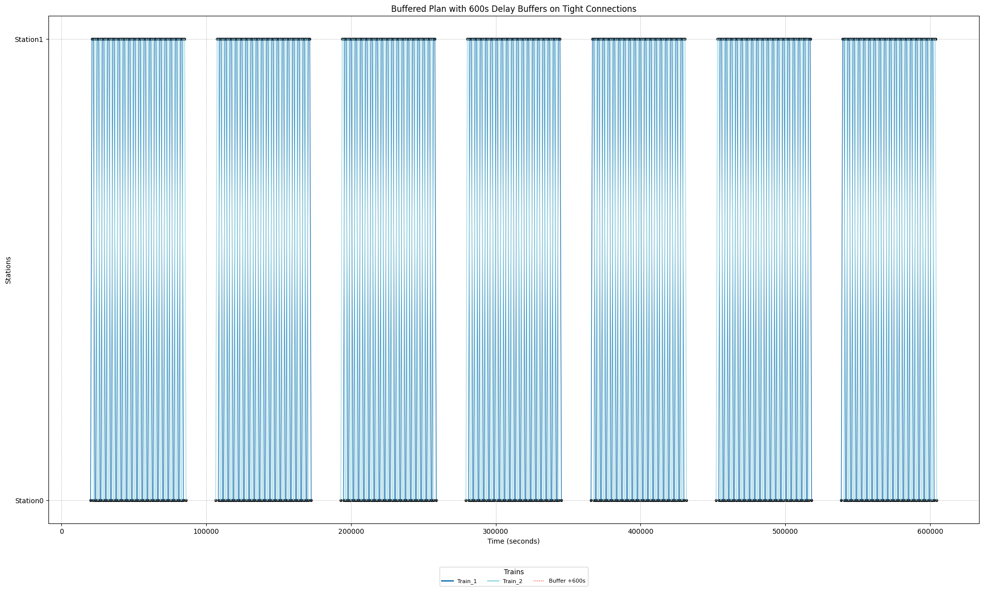

**Instance D**

**Unoptimized Space Time Network**

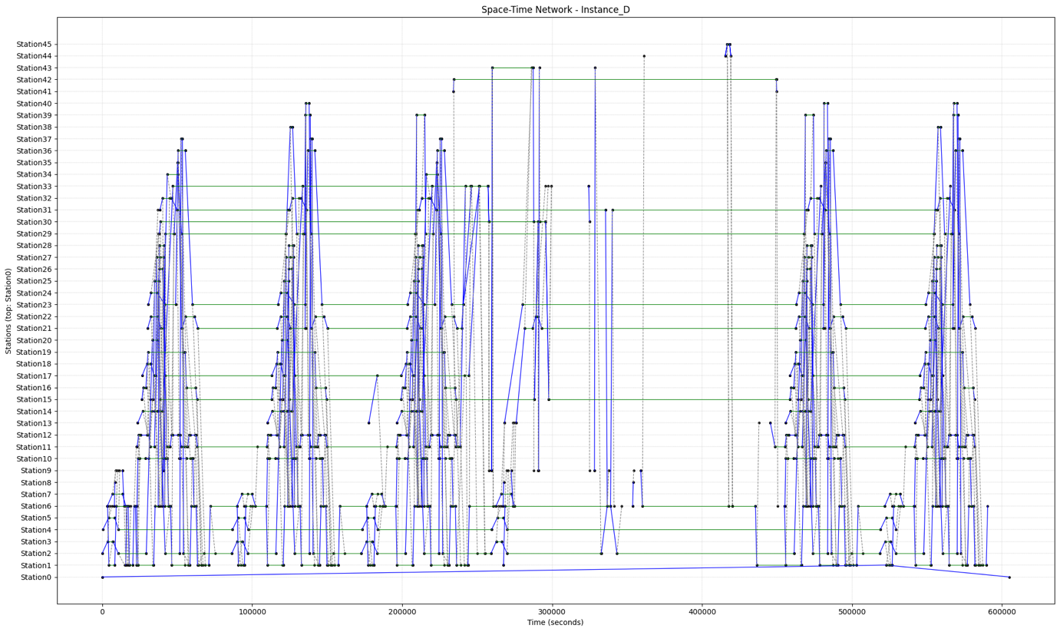

**Optimized Space-time Network**

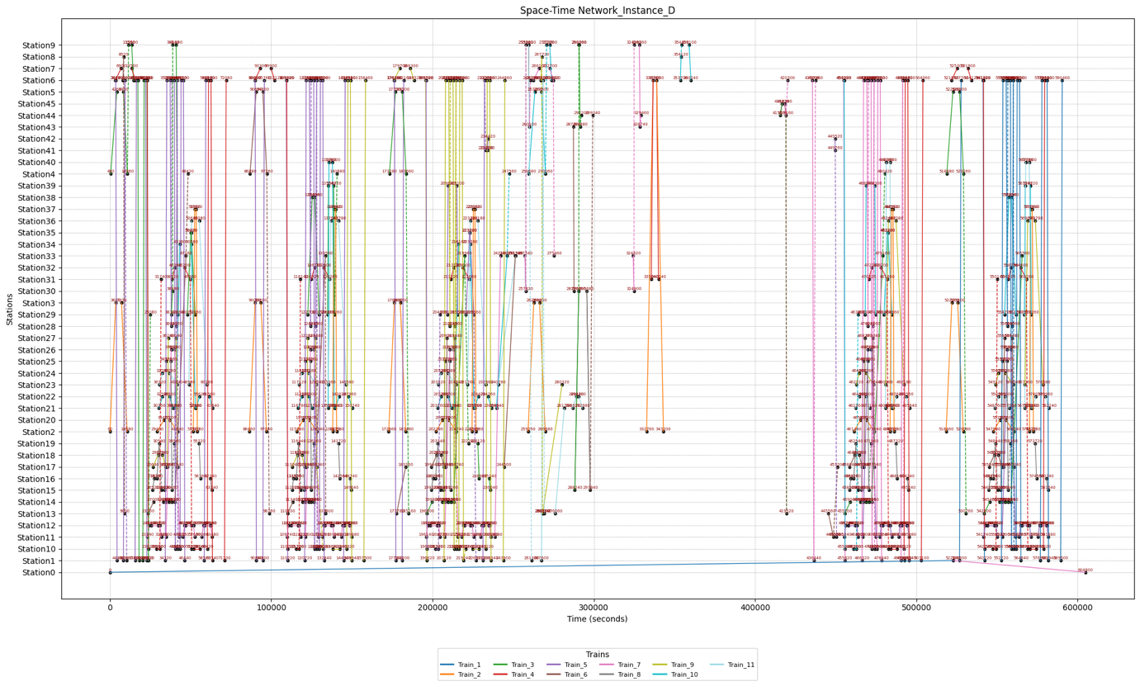

**Robust Space Time Network**

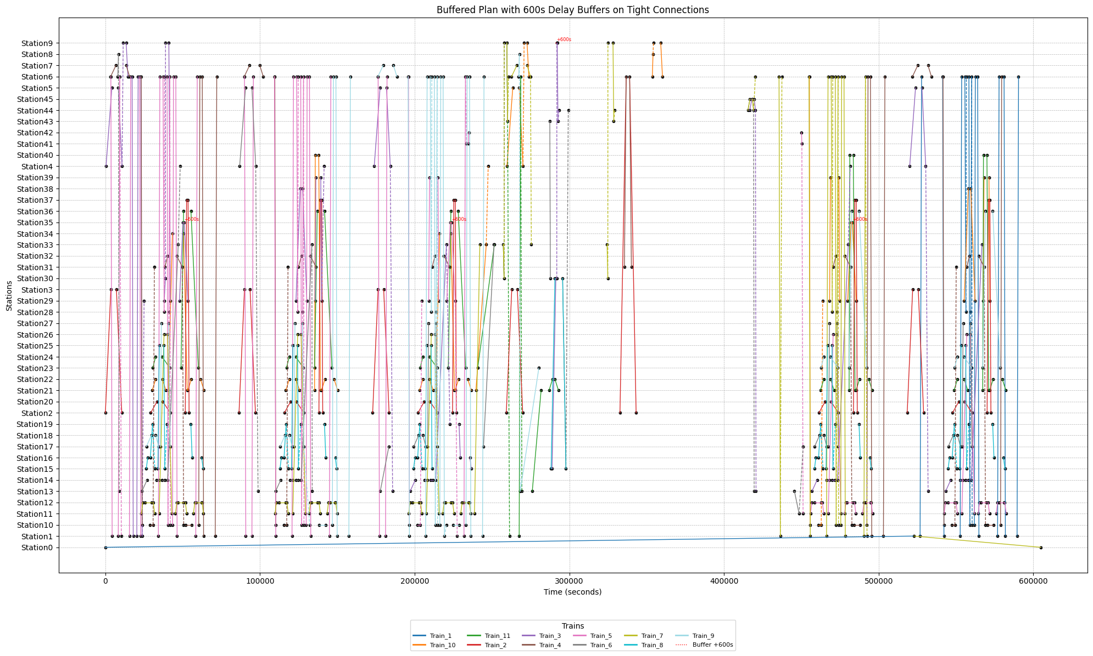

**Instance E**

**Unoptimized Space Time Network**

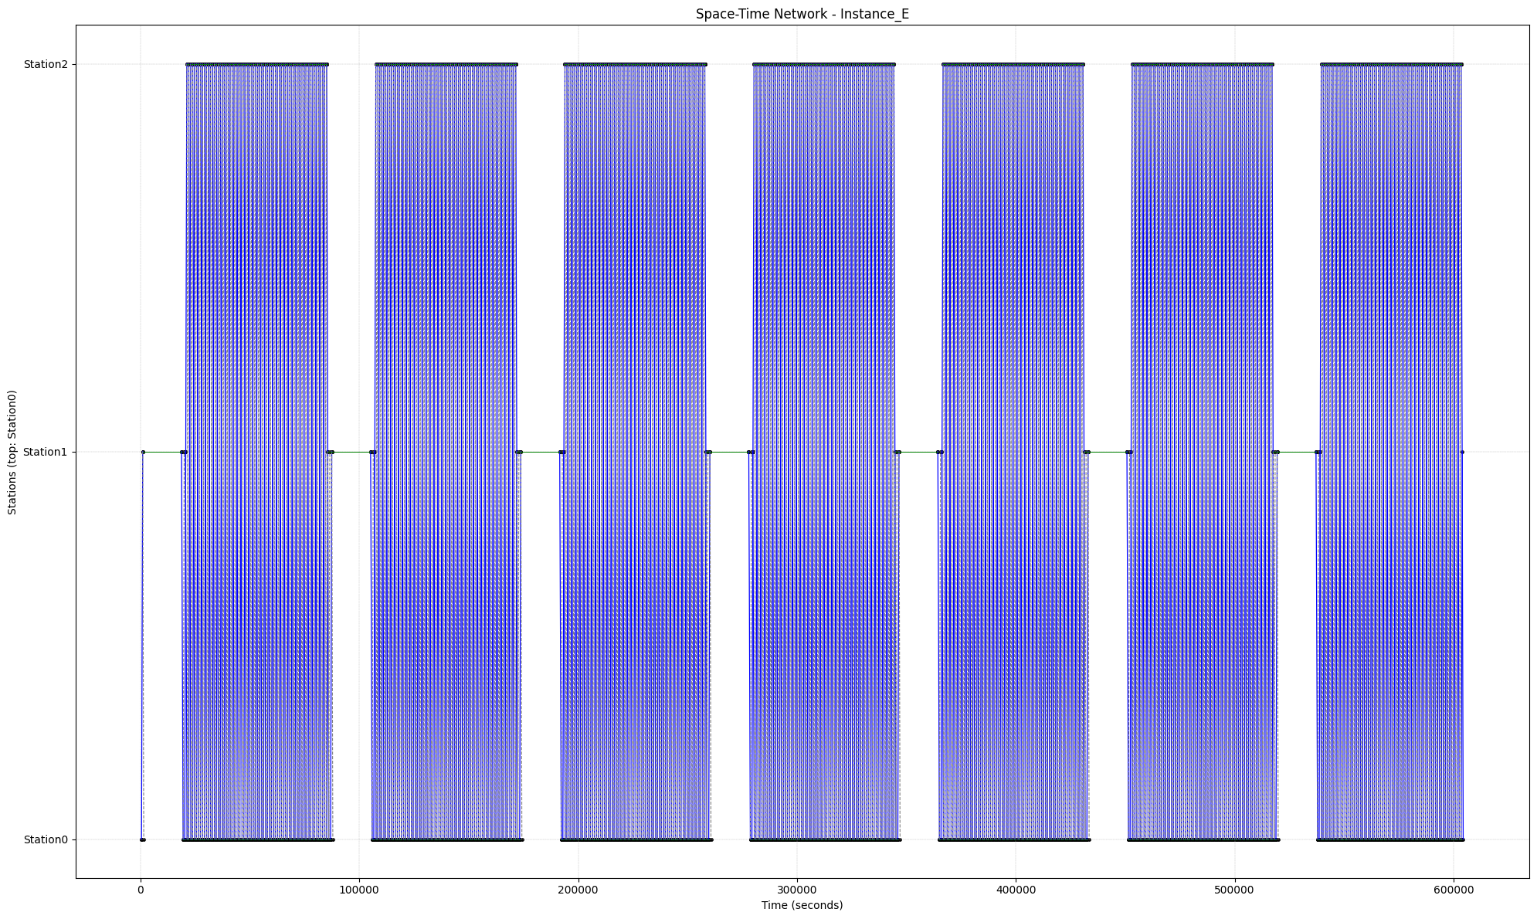

**Optimized Space-time Network**

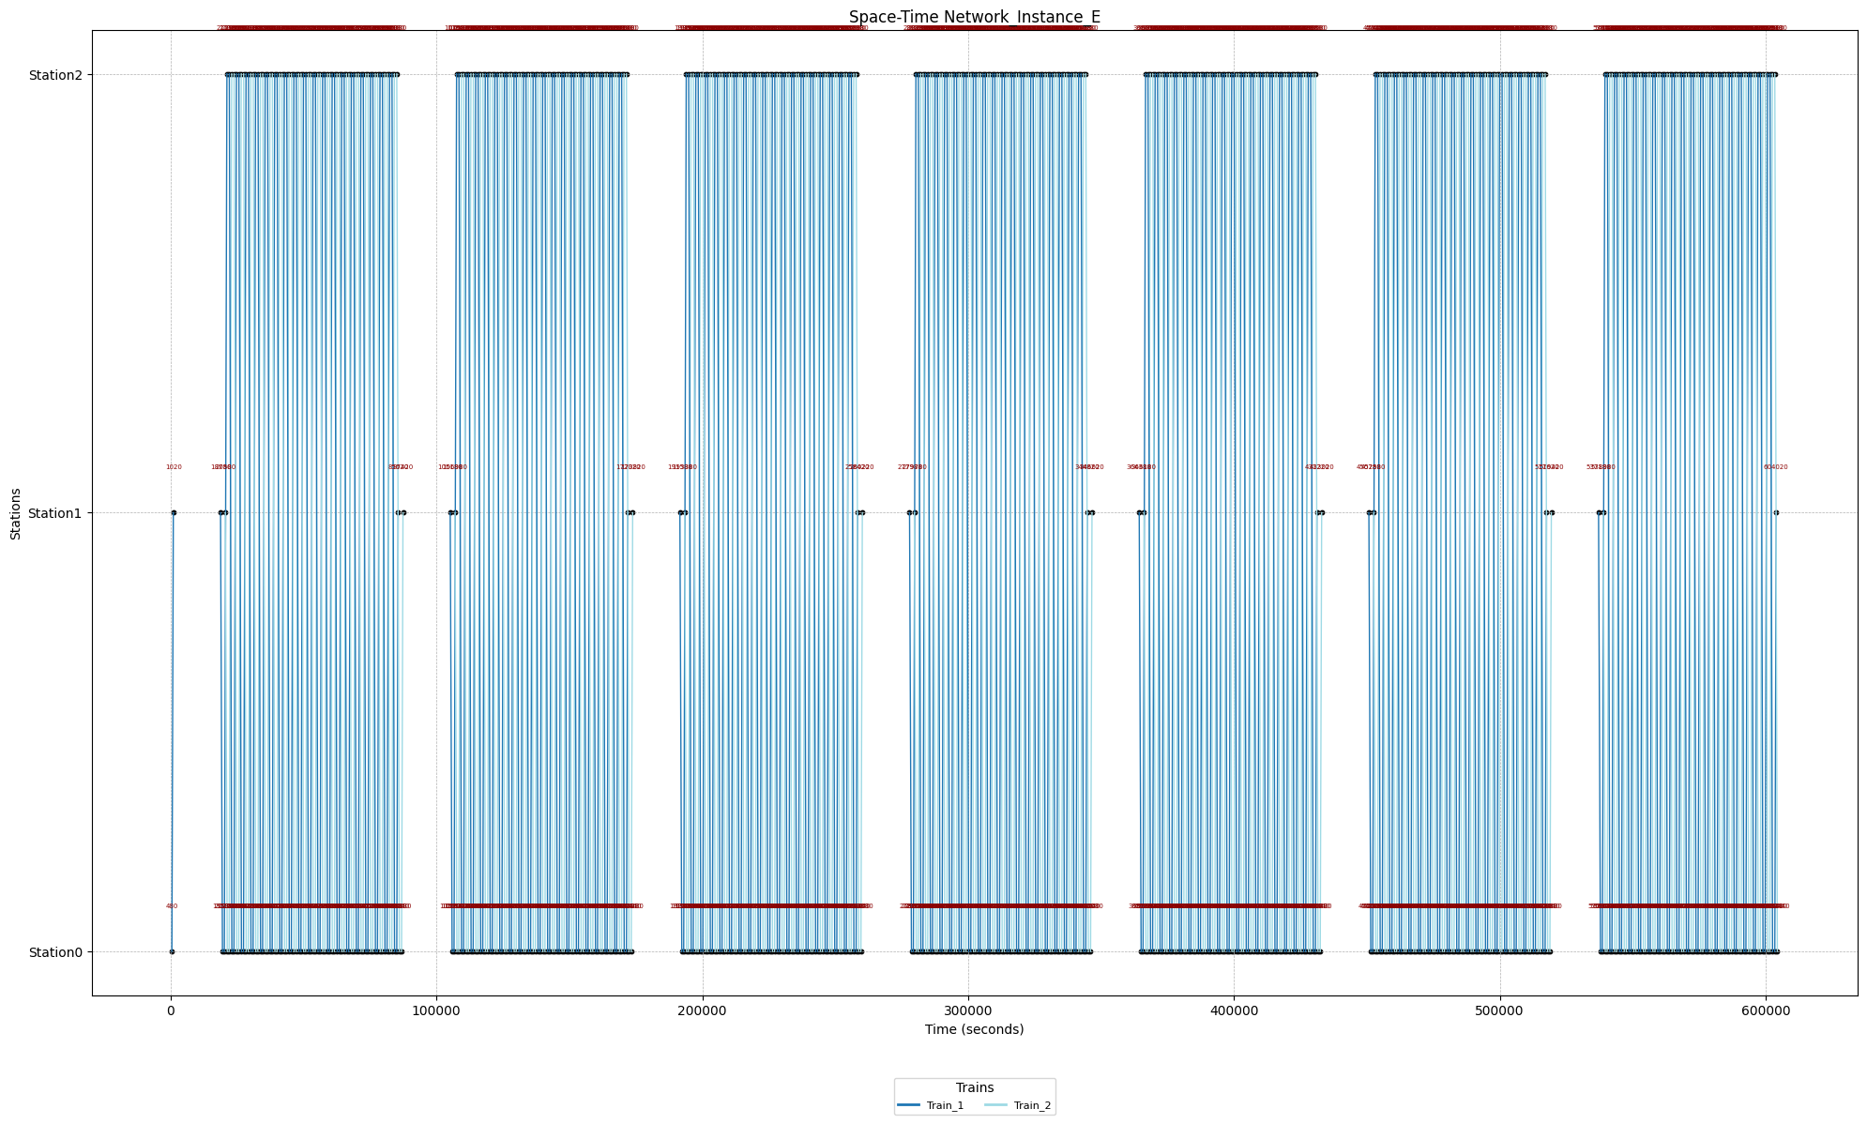

**Instance F**

**Unoptimized Space-time Network**

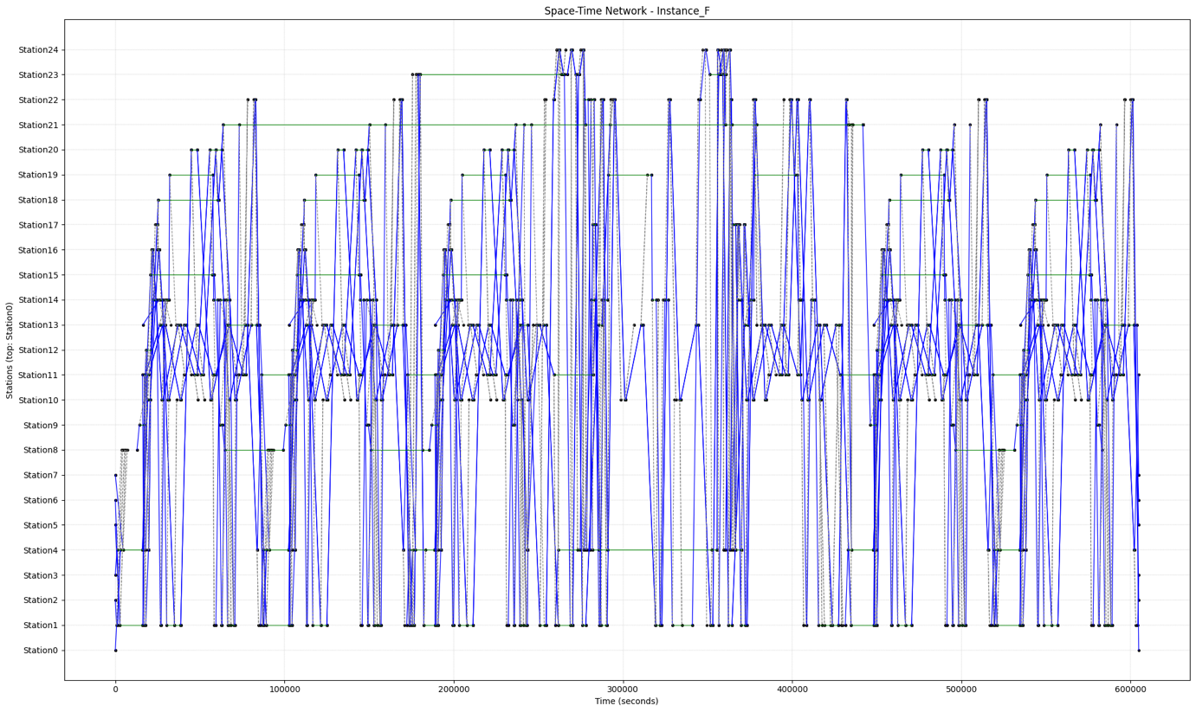

**Optimized Space-time Network**

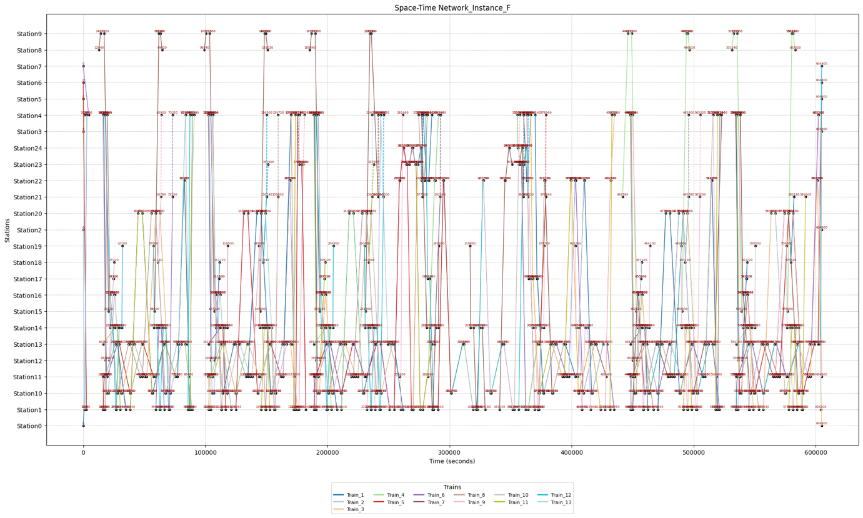

**Robustness Space-time Network**

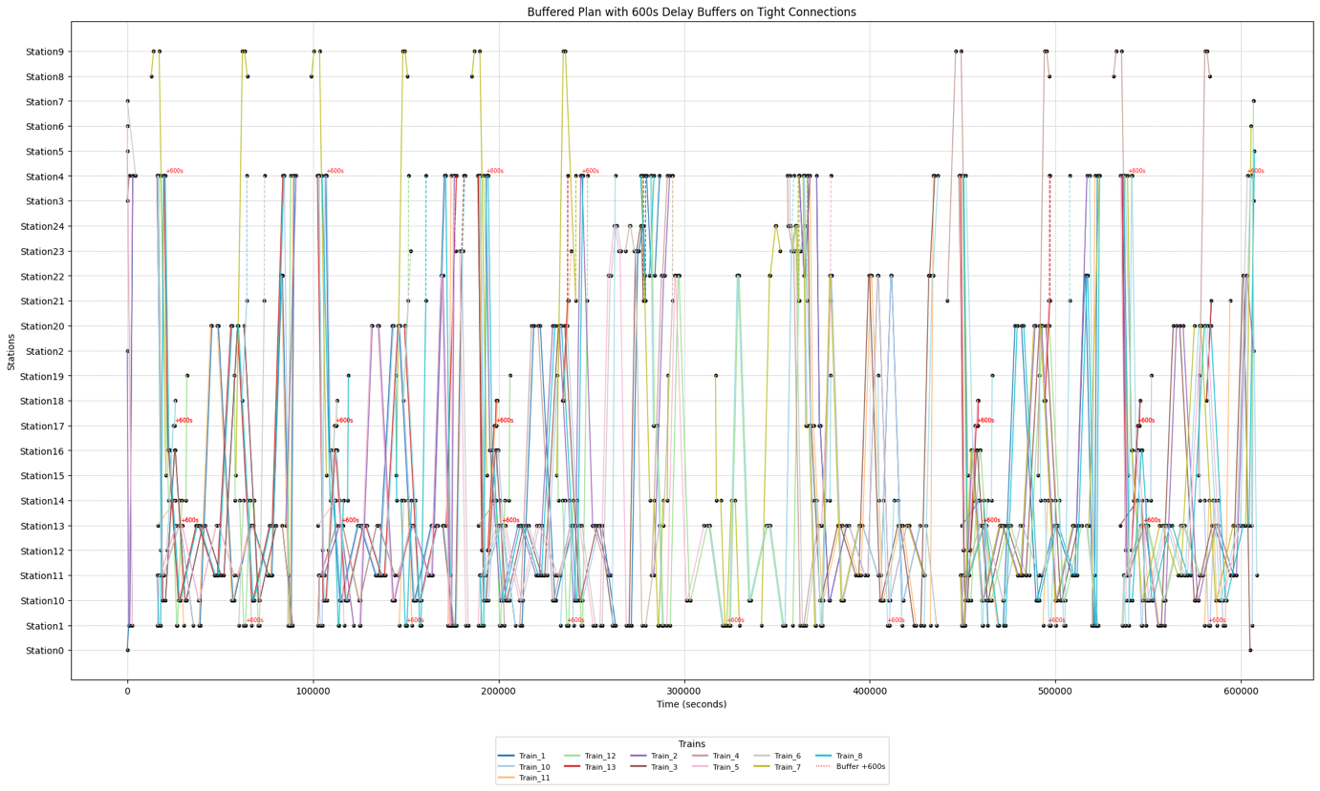

**Instance G**

**Unoptimized Space-time Network**

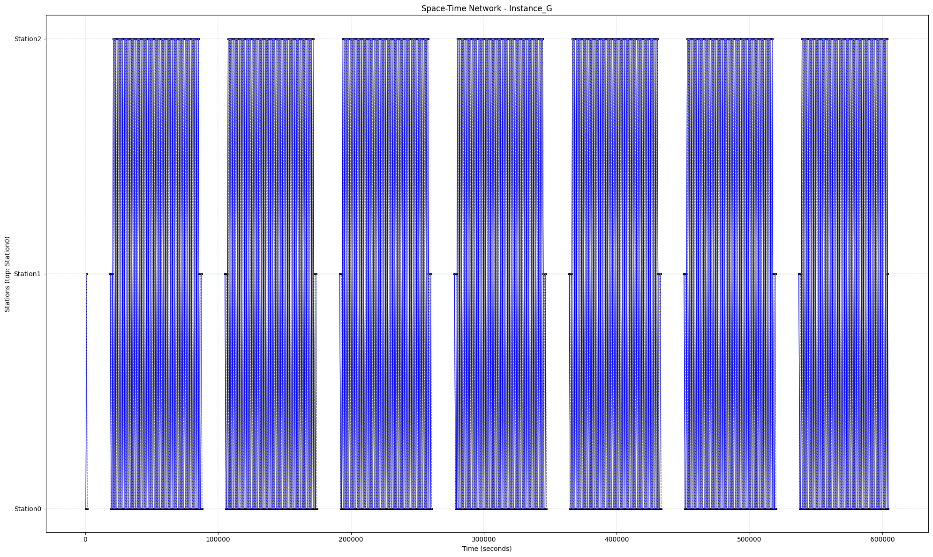

**Optimized Space-time Network**

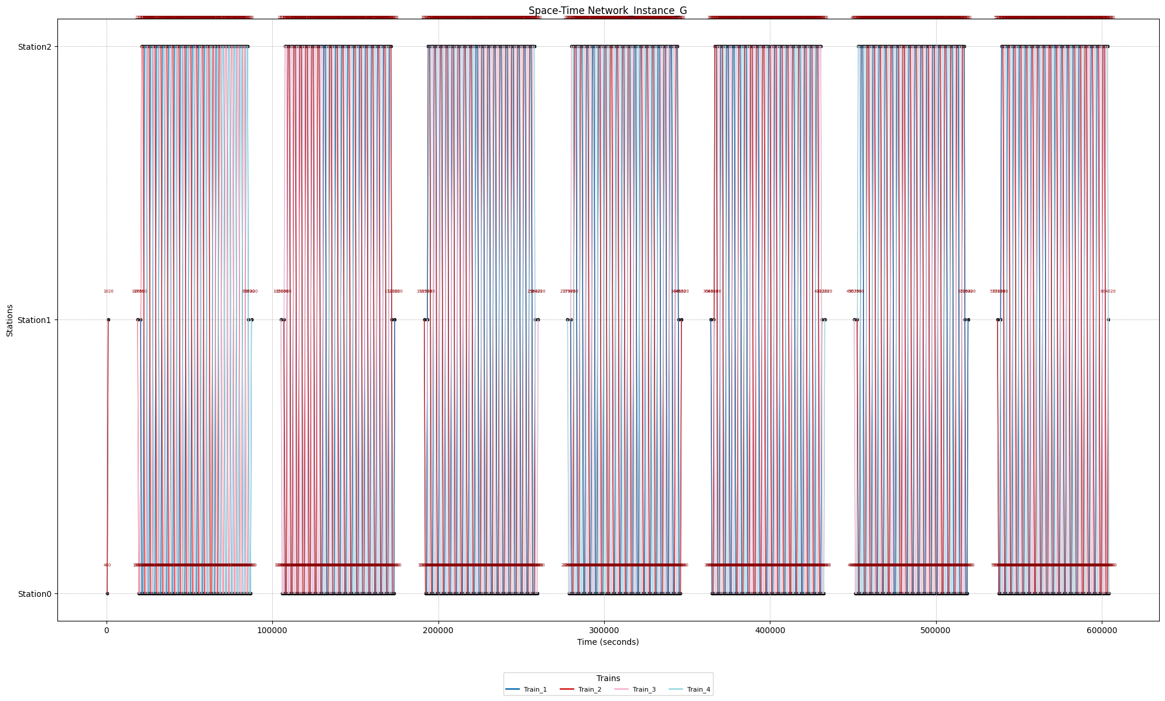

**Robustness Space-time Network**

